Practicum Case | 
COMP7116 | COMP7116001 | COMP7116016 | MATH6168 | MATH6168016
Computer Vision
Computer Science | O211-COMP7116-TD01-03
Valid on Odd Semester 2020/2021 | Revision 00

Learning Outcomes
- Various computational principles and standard image processing operators in computer vision
- The local features with their detectors and descriptors in computer vision
- Various features to find correspondence between images and perform recognition in computer vision
- Various image recognition system in computer vision

Topics
- Session 3 – Image Processing

Subtopics
- Grayscale
- Filtering
- Threshold
Image Processing
Image processing is a method to perform some operations on an image, in order to get an enhanced image or to extract some useful information from it. It is a type of signal processing in which input is an image and output may be image or characteristics/features associated with that image. Nowadays, image processing is among rapidly growing technologies. In this course we will try to do some basic image processing, where the input and the output is an image. Our aim in this course is to understand what things we can do to our image using image processing. In this tutorial we will learn about changing color space, simple thresholding, and simple filtering.

Before we start, make sure to install and import python libraries bellow
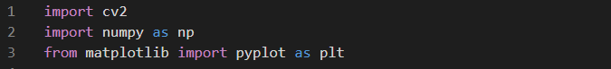
Figure 1. Importing libraries
In this course we will need opencv to do the image processing, numpy for the ndarray, and matplotlib for the plotting.
- Change the color space
There are more than 150 color-space conversion methods available in OpenCV. But in this course, we will only use BGR to Gray. To do so, we can look at the bellow example.
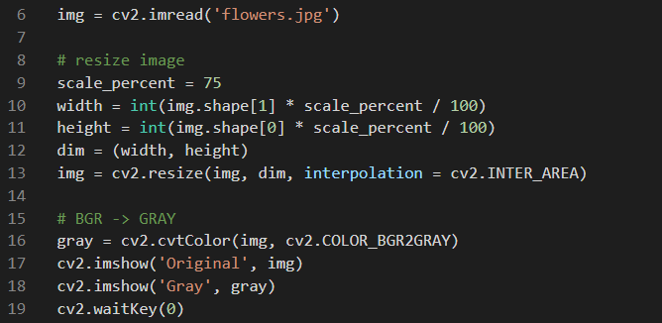
Figure 2. Resizing and changing the color space
As we can see from the above code, we can also use opencv to change the color space of our image. And in the above example we resized the image before changed the color space, because the image we use in this example is too big. Remember, resizing the image does not correlate with changing the color space. So, resizing the image is optional.
e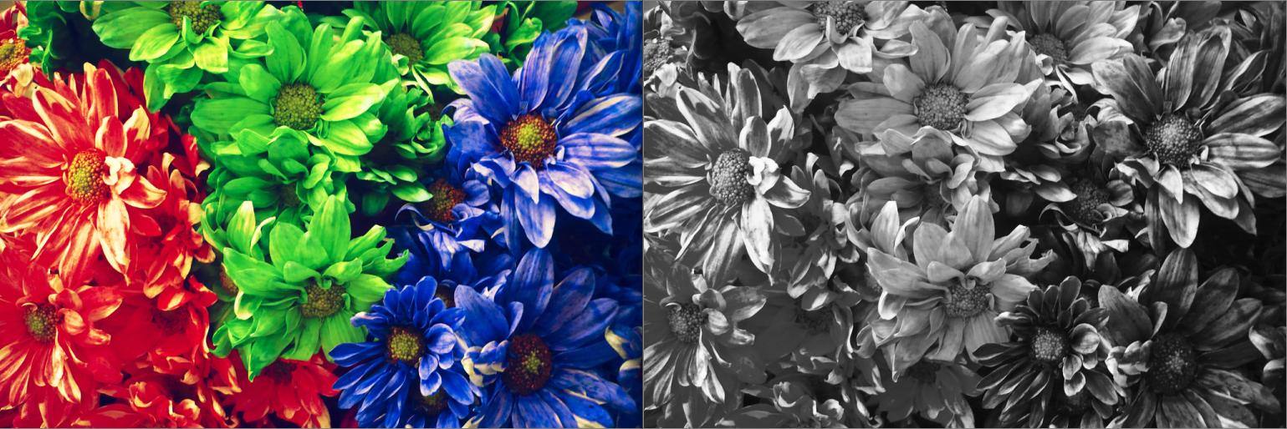
Figure 3. Before and after the color space changed
- Simple Thresholding
In digital image processing, thresholding is the simplest method of segmenting images. From a grayscale image, thresholding can be used to create binary images. If pixel value is greater than a threshold value, it is assigned one value, else it is assigned another value. To do so, we can use the function “.threshold()”. First argument is the source image, which should be a grayscale image. Second argument is the threshold value which is used to classify the pixel values. Third argument is the max value which represents the value to be given if pixel value is more than the threshold value. Opencv provides different styles of thresholding and it is decided by the fourth parameter of the function. The difference for each thresholding style is the formula used to determine the optimal threshold value.
Enumerator | Threshold Type
THRESH_BINARY | 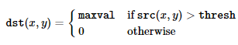
THRESH_BINARY_INV | 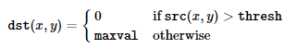
THRESH_TRUNC | 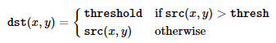
THRESH_TOZERO | 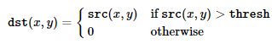
THRESH_TOZERO_INV | 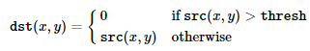
THRESH_OTSU | Using Otsu algorithm to choose the optimal threshold value
THRESH_TRIANGLE | Using Triangle algorithm to choose the optimal threshold value

By using different enumerator in the fourth argument, we are changing the threshold type we are using. We can see the example code to apply the thresholding below.
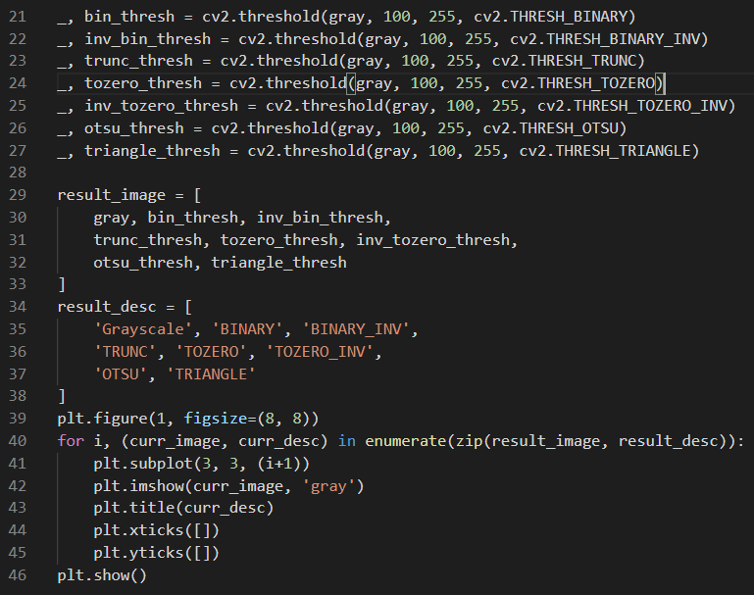
Figure 4. Apply different types of thresholding

In the above code, “.threshold()” method returns two outputs. The first output is a retval which will be explained later in the other course, and the second output is our threshold image. We are trying to display all the result of the thresholding side by side. To do so, We need to store the thresholding result and the description to some arrays. After we put it into certain array, we can just put it into subplot using a repetition before display the figure. The first parameter of the “.figure()” method is the figure number, and the second parameter is the figure size in inches. The first parameter of the subplot method represents the number of rows, the second parameter represents the number of columns, and the third parameter is the index of the subplot.
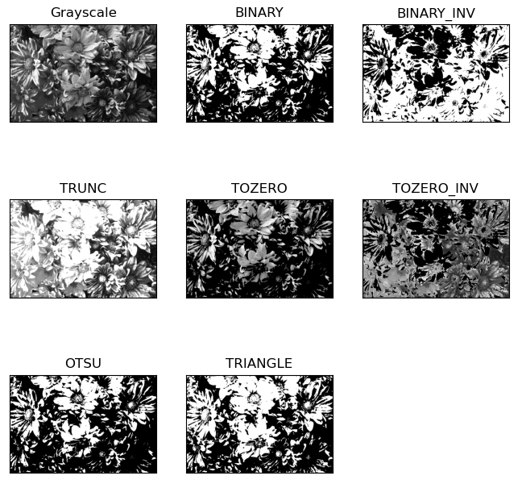
Figure 5. Thresholding results

- Filtering
Filtering is a technique for modifying or enhancing an image. Filtering is a neighborhood operation, in which the value of any given pixel in the output image is determined by applying some algorithm to the values of the pixels in the neighborhood of the corresponding input pixel. As in one-dimensional signals, images also can be filtered with various low-pass filters(LPF), high-pass filters(HPF) etc. In this course we will learn more about image blurring. Image blurring is achieved by convolving the image with a low-pass filters(LPF) kernel. It is useful for removing noises. It removes high frequency content from the image. And the opencv library provides mainly four types of blurring technique.
- Averaging is a blurring technique that is done by convolving image with a normalized box filter. It simply takes the average of all the pixels under kernel area and replace the central element. This is done by the method “.blur()”.
- Gaussian blur is a blurring technique where gaussian kernel is used instead of box filter. It is done with the method “.GaussianBlur()”. We should specify the width and height of kernel which should be positive and odd. We also should specify the standard deviation in X and Y direction, sigmaX and sigmaY respectively. If only sigmaX is specified, sigmaY is taken as same as sigmaX. If both are given as zeros, they are calculated from kernel size. Gaussian blurring is highly effective in removing gaussian noise from the image.
- Median blur is a blurring technique that takes median of all the pixels under kernel area and central element is replaced with this median value. This is highly effective against sall-and-pepper noise in the images.
- Bilateral filter is a blurring technique that is highly effective in noise removal while keeping edges sharp. But the operation is slower compared to other filters.
Below sample shows the code to apply all each of the blurring technique.
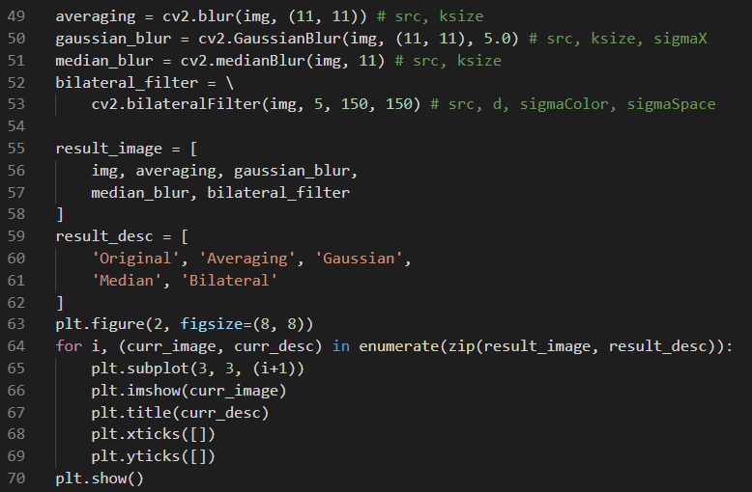
Figure 6. Apply blurring techniques
In the above code, we can see that each blurring technique method has difference number of arguments. But we can notice that every method that we used above take source image as the first argument. And the second argument for the averaging, gaussian , and median blur is ksize. Ksize stands for kernel size. The kernel size in the “.medianBlur()” method has to be aperture linear size, it must be odd and greater than 1, for example: 3, 5, 7, and so on. The third argument of “.GaussianBlur()” method represents gaussian kernel standard deviation in X direction. And for the “.bilateralFilter()” method, it takes d for the second argument. D is a diameter of each pixel neighborhood that is used during filtering/ if the d value is non-positive, it is computed from sigma space(fourth argument). The third argument is a sigma color, which a larger value of the parameter means that farther colors within the pixel neighborhood will be mixed together, resulting in larger areas of semi-equal color. And the fourth argument is a sigma space, which larger value of the parameter means that farther pixels will influence each other as long as their colors are close enough.
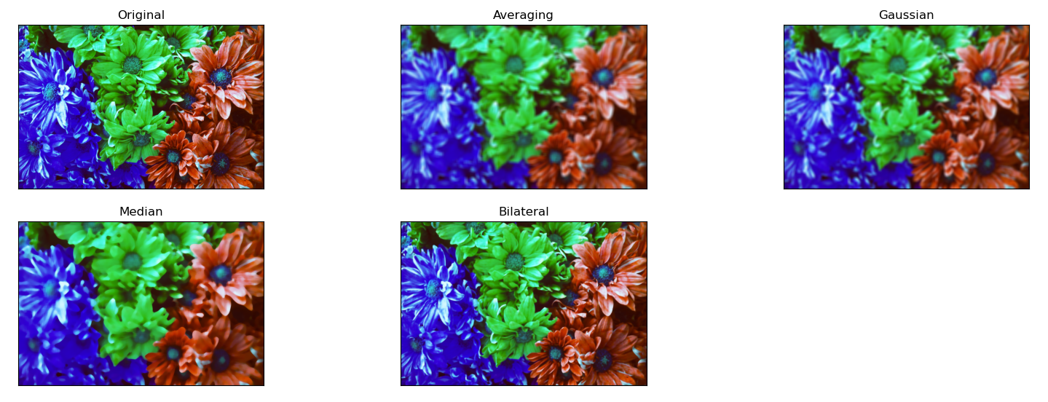
Figure 7. Blurring technique results

References:
https://www.flickr.com/photos/alfon18/2493066758

